Lesson 2.6 Measuring temperature

Recommended teaching time for this lesson: 0.5 x 60 minute period

• 15 minutes of explicit teaching

• 15 minutes of suggested classroom activities

• 30 minutes homework

Getting started

Learning intentions & success criteria

|  |  |
| --- | --- |
| I will: | I can: |
| understand different temperature measurement scales. | * describe:   + the Fahrenheit scale   + the Celsius scale   + the Kelvin scale. * discuss:   + problems associated with using different measurement scales internationally. |
| be able to convert temperature measurements between the Kelvin and Celsius scales. | * identify:   + the formula for converting temperature measurements between the Kelvin and Celsius scales. * use:   + the identified formula to convert temperature measurements between the Kelvin and Celsius scales. |
| understand the precision and accuracy of analogue and digital thermometers. | * recall:   + the definition of precision   + the definition of accuracy. * determine:   + the uncertainty of a described analogue thermometer   + the uncertainty of a described digital thermometer   + which of described analogue and digital thermometers has the least uncertainty. |

Key ideas

* The thermometer is a good example of thermal expansion as explained by the kinetic particle model of matter.
* The Fahrenheit, Celsius and Kelvin scales are used to measure temperature.

Curriculum links

Science understanding

* Use 𝑇𝐾 = 𝑇𝐶 +273 to convert temperature measurements.

Science as a human endeavour

* Appreciate that different temperature scales (e.g. Celsius, Fahrenheit, Kelvin) were developed at different times to serve different purposes.

Science inquiry

* Consider the significance of using common units of measurement internationally.
* Investigate the precision and accuracy of different temperature measuring devices, such as analogue and digital thermometers, by determining measurement uncertainty.

Advice for teaching this lesson

Things to know before you start teaching

The relationship between Celsius and Kelvin scales will be important in any year your students do Quantum Theory as the only places that involve temperature calculations are changes of temperature in the heating topic (Unit 1 General Sequence, Unit 3 Alternate Sequence) and Quantum Theory (Unit 4 for both General and Alternate Sequences). This can then be moved through fairly quickly with some reteaching done when entering Quantum Theory.

Common misconceptions

* When referring to the scale, the word Kelvin is capitalised, however when writing a word with the full unit – like 27 kelvin – the unit is lowercase to go with lexicographic conventions. Students commonly will use 27 Kelvin instead. If they ask why for ‘degree Celsius’ is the word ‘Celsius’ capitalised, it is because the first part of the word is lowercase, but Celsius is a modifier of the unit degree and so is given the capitalisation for a name. This will appear in Table 1 of the text as well.

Differentiation strategies

For lower performing students who are confused on when to use Kelvin versus Celsius at this stage, the answer is effectively “both are fine”. You may want to instruct them to always use Kelvin as it will prevent an issue occurring when they reach the Quantum Theory topic.

Other considerations

You could adapt the classroom activity to be a taught activity, as this will help students understand how to answer Question 8 of the Check your learning questions.

Starter activity: Humour in temperature scales

Approximate time: 5 minutes

**Activity placement:** Place directly after Lesson overview

**Activity summary:** Comparing what would happen to humans at 0 and 100 for different temperature scales.

Notes for the teacher

Have students examine the image. Ask them to consider what scale we use, what they see in the media, and what each onme might be based on.

Instructions for students

Examine the image below. Consider where you have seen the scales – you may not have seen one or two of them – and what they might be based on.

A funny comparison of temperature scales

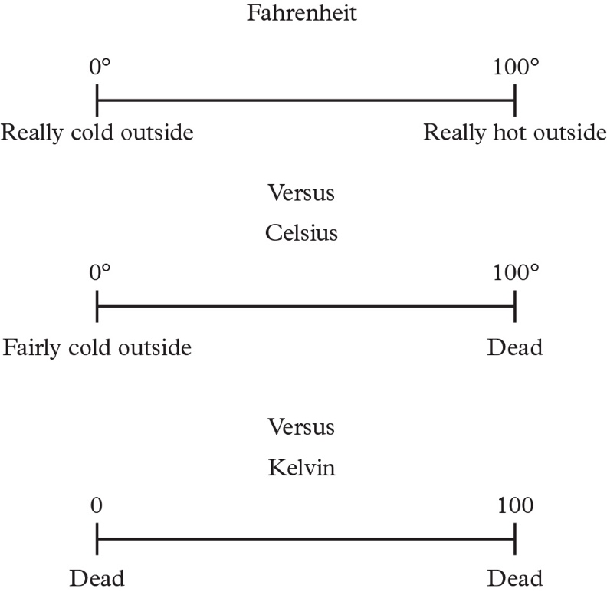

* 1. Discuss your thoughts and observations with the class.

Answers

<Note to production: restart numbering below at ‘a.’>

* 1. Student answers will vary; however, students may discuss the appearance of temperature scales in relation to the media. Students who are exposed to American TV will probably have heard about Fahrenheit. Students with more of a scientific interest may have heard of Kelvin.

Classroom activity: Practicing with temperature scales

Approximate time: 10 minutes

**Activity placement:** Place directly above “Real-world physics”

**Activity summary:** A small equation practice activity to demonstrate to students when Celsius or Kelvin can be used, and where only Kelvin can be used.

Notes for the teacher

Capable students may have internalised the statement in the text “One degree on the Kelvin scale is equal in magnitude to one degree on the Celsius scale” and feel that this activity is obvious. A challenge task is included for them but reminding them that testing and proving something is an important part of education can be good reinforcement.

Assure students that the temperature/kinetic energy equation is not relevant to the syllabus and only used for context. The question could be adjusted to use Wien’s displacement law from quantum theory if you would prefer something that is assessable.

You may need to give a reminder that energy is a scalar and that an object cannot have negative energy.

Instructions for students

Step 1: Use the Kelvin and Celsius temperature scales to perform the same calculation.

<Note to production: restart numbering below at ‘a.’>

* 1. Calculate the difference in temperature in Kelvin and Celsius for water of 83°C falling to 25°C.
  2. What can you state about the difference in temperature under these two measurements?

Step 2: Consider the equation , which is used to work out the heat energy when temperature changes. *Q* represents heat and *ΔT* represents change in temperature. You will learn about this more in a later lesson.

<Note to production: restart numbering below at ‘c.’ **NOT** ‘a’.>

* 1. If *Q* is proportional to *ΔT*, does this equation work in the same way if you use temperature in Kelvin or Celsius?

Step 3: Consider the equation $E_{k}=\frac{3}{2}kT$, which describes the relationship between kinetic energy, Ek, and temperature, *T*, of a gas. The constant k = 1.38 × 10-23 J K-1.

<Note to production: restart numbering below at ‘d.’ **NOT** ‘a’.>

* 1. Determine the kinetic energy of oxygen gas at a temperature of -50°C. Test the answer with both Kelvin and Celsius values.
  2. Compare the kinetic energies you calculated in d. Which answer should you reject?

Step 4: Determine a general rule for the following.

<Note to production: restart numbering below at ‘f.’ **NOT** ‘a’.>

* 1. When should you use Kelvin values in equations and when is it acceptable to use Celsius values?

Helpful hints

* Proportional means that as one thing changes, the other thing changes at the same rate. Petrol prices are a good example of a proportional measurement you see frequently as when you want to buy more litres of petrol, the total cost goes up.

Support activity

Notes for the teacher

The support activity is largely the same as the classroom activity; however, it will reword the questions to give the student more guidance to the correct answers and recognise when to use Celsius and Kelvin in equations.

Instructions for students

Step 1: Use the Kelvin and Celsius temperature scales to perform the same calculation.

<Note to production: restart numbering below at ‘a’.>

* 1. Calculate the difference in temperature in Kelvin and Celsius for water of 83°C falling to 25°C. Remember: Calculate a difference by taking the final value and subtracting the initial value.
  2. What can you state about the difference in temperature under these two measurements?

Step 2: Consider the equation $Q=mc∆T$, which is used to work out the heat energy when temperature changes. *Q* represents heat and *ΔT* represents change in temperature. You will learn about this more in a later lesson.

<Note to production: restart numbering below at ‘c.’ **NOT** ‘a’.>

* 1. In the equation $Q=mc∆T$ let *m* = 1, and *c* = 1. Will you get the same answer for *Q* if change in temperature, *ΔT*, is in degrees Celsius or kelvin?

Step 3: Consider the equation $E_{k}=\frac{3}{2}kT$, which describes the relationship between kinetic energy, Ek, and temperature, *T*, of a gas. The constant k = 1.38 × 10-23 J K-1.

<Note to production: restart numbering below at ‘d.’ **NOT** ‘a’.>

* 1. Determine the kinetic energy of oxygen gas at a temperature of -50 °C. Test the answer with both *T* = -50 °C and *T* = 223 K.
  2. Compare the kinetic energies you calculated in step d. It is impossible for something to have ‘negative energy’ (note that heat is the movement of energy, which is why it can be negative). Identify which temperature measurement gets you to the correct answer.

Step 4: Consider when to use Kelvin values in an equation and when to use Celsius values.

<Note to production: restart numbering below at ‘f.’ **NOT** ‘a’.>

* 1. If you are calculating a value using the change in temperature, can you use Kelvin and get a correct answer? Can you use Celsius and get a correct answer?
  2. If you are calculating a value using a single temperature measurement, can you use Kelvin and get a correct answer? Can you use Celsius and get a correct answer?

Challenge activity

Notes for the teacher

This activity requires a more rigorous proof for Step 2 and students will be unfamiliar with two terms, although they can probably guess one. You could encourage them to try and look ahead to figure out the value.

You could start them off by suggesting that they expand the *ΔT* and insert $T_{k}=T_{c}+273$ into it.

Instructions for students

Step 1: Use the Kelvin and Celsius temperature scales to perform the same calculation.

<Note to production: restart numbering below at ‘a’.>

* 1. Calculate the difference in temperature in Kelvin and Celsius for water of 83°C falling to 25°C.
  2. What can you state about the difference in temperature under these two measurements?

Step 2: Consider the equation , which is used to work out the heat energy when temperature changes. *Q* represents heat, and *ΔT* represents change in temperature. You will learn about this more in a later lesson.

<Note to production: restart numbering below at ‘c.’ **NOT** ‘a’.>

* 1. Prove for the equation $Q=mc∆T$ that you can use Kelvin or Celsius for any temperature measurement.

Step 3: Consider the equation $E_{k}=\frac{3}{2}kT$, which describes the relationship between kinetic energy, Ek, and temperature, *T*, of a gas. The constant k = 1.38 × 10-23 J K-1.

<Note to production: restart numbering below at ‘d.’ **NOT** ‘a’.>

* 1. Determine the kinetic energy of oxygen gas at a temperature of -50°C. Test the answer with both Kelvin and Celsius values.
  2. Compare the kinetic energies you calculated in step d. Which answer should you reject?

Step 4: Determine a general rule for the following.

<Note to production: restart numbering below at ‘f.’ **NOT** ‘a’.>

* 1. When should you use Kelvin values in equations and when is it acceptable to use Celsius values?

Answers

<Note to production: restart numbering below at ‘a’.>

* 1. 
  2. They have the same magnitude/size.
  3. Yes it will work whether the change in temperature is in Celsius or Kelvin.
  4. Kelvin: 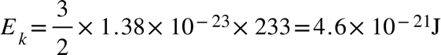  
     Celsius: 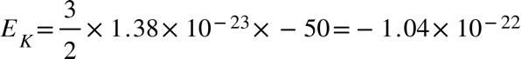
  5. You should reject the value calculated from *T* = -50 as this produces a value of ‘negative energy’, which is not a possible property of a substance. You can have negative heat as it is energy leaving a substance.
  6. If the equation just has *T*, you should use Kelvin. If the equation has *ΔT* you can use either.

Support activity

<Note to production: restart numbering below at ‘a.’>

* 1. 
  2. They have the same magnitude/size
  3. Yes, you will get the same answer.
  4. Kelvin:  
     Celsius:
  5. The Kelvin temperature is the correct answer as Celsius gives you negative energy.
  6. If you are calculating using a change in temperature, both Kelvin and Celsius will get you the right answer.
  7. If you are calculating using a measurement of temperature only Kelvin will work.

Challenge activity

<Note to production: restart numbering below at ‘a.’>

* 1. 
  2. They have the same magnitude/size.
  3. Using Celsius: 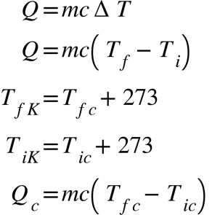 
     Using Kelvin: 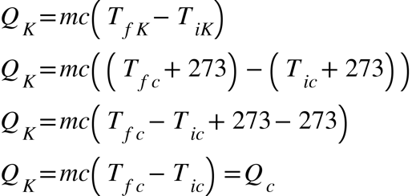 
     Therefore, using Kelvin or Celsius temperature values in this equation work the same.
  4. Kelvin:  
     Celsius:
  5. You should reject the value calculated from *T* = -50 as this produces a value of ‘negative energy’, which is not a possible property of a substance. You can have negative heat as it is energy leaving a substance.
  6. If the equation just has *T*, you should use Kelvin. If the equation has *ΔT* you can use either.